 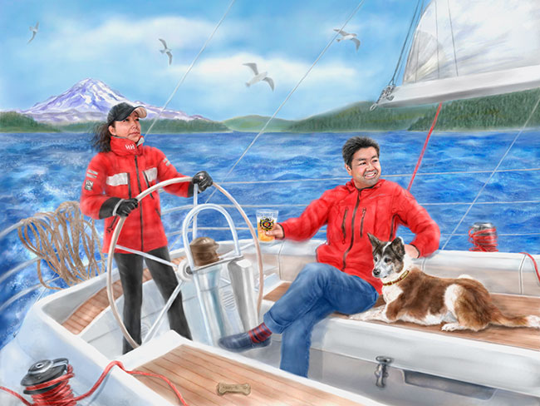

**West Shore Sail Club**

**In conjunction with:**

**Ford and Grosse Ile Yacht Clubs**

Presents the annual

Jack and Jill Race

Sunday, Sept 6, 2020; 1 pm

**Note: Both FYC and GIYC offer an additional award**

**for the best finish to the boat owned by a member of their club**

**Race and afterglow is open to ALL sailors and friends. Come one – Come all**

**Sign up on Notice of Race**

Jack and Jill Afterglow/Corn Roast

Sunday, Sept 6, 2020; 4:30 p.m. at:

Gibraltar Boat Yard

28731 North Gibraltar Road

Gibraltar, MI 48173

**Note: The Afterglow/Corn roast is a BYOB and Dish-to-Pass event.**

**The Corn Roast costs only $5 for supplied corn on the cob, chicken, potatoes, and the passed dishes**

Noticeofrace.net

Westshoresailclub.org